[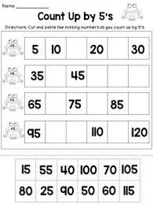](https://www.google.com/url?sa=i&url=https%3A%2F%2Fwww.pinterest.com%2Fpin%2F126874914489329103%2F&psig=AOvVaw3se935CHM_SoBUJj6c1JDw&ust=1590676146952000&source=images&cd=vfe&ved=0CAIQjRxqFwoTCNjAt8yg1OkCFQAAAAAdAAAAABAJ)